**Names:Gabriel DUSHIME**

**Reg No:221016855**

**Phone:+250783447260**

**Email:**[**gabrieldushime004@gmail.com**](gabrieldushime004@gmail.com)

**School:School Of ICT**

**College:College Of CST**

**Campus:Huye Campus**

Kabaka’s Car Market



**1.Introduction**

**1.1 Project Summary**

Kabaka’s Car Market Website is a website that help many people who want to purchase cars, the way through which they can have their own cars.

This website helps the people to Request for a used car.so that we can deliver it to him/her.

Also this site a people can have an account so that he/she can find a car according to his/her wishes.

**1.2 Problem statement**

The addressment I wish is to avoid those people who eat money of the people through selling for them the used car for a high price.

**1.3 Project Objective**

The main objectives of my project is to help the people buying a used car for row prices, instead of being by cars to the high prices.

**1.4 Project Rationale**

The main important of my project and the beneficially is that people get car easily without moving finding the cars from one place to other, by this people can demand a car.

**2.Methodologies And Method**

**2.1 Data Collection Method**

The Method through which I collected data is through searching on the internet and through asking my friend some news.

**2.1 Tools To Be Used**

**2.1.1 Hardware Tools**

The hardware tools I used through designing my web pages is a laptop computer, Pens And Papers

**2.1.1 Software Tools**

The Software Tools I used are including different software like

* Xampp
* Visual studio code
* Google Chrome

**3.System Analysis And Design**

**3.1 Requirement Specification**

The number of pages I included within my website are Include 7main pages:

* Home
* Services
* Contact us
* About Us
* Demand
* Gallery

### **3.1.1 Functional requirements**

Within my project I had put different functionality which includes the forms for registering to the user of the system, also there is the form for the demanding a car when someone need a car. And Also there is contact us form where someone can send us a message from any support or an idea.

### **3.1.2 Data Requirements**

Within the data requirement for my project there is different tables containing some data,Like the sign up table, demand table all these containing many data entered by the user who are signing up and demanding for a car.

### **3.1.3 User Requirements**

The main user of my system are includes the user and admin who will be in charge of the business, and also a person who will be at the website user in the job who will be in charge of watching all request and messages coming to the website.

**3.1.4 Security Requirements**

With my project all data are safe since every user will be having his/her own account and its password so that there is no other one who can access his/her data. And also the admin will be having his own credential to control the website.

**3.2 System Design**

### **3.2.1 System Overall Architecture**

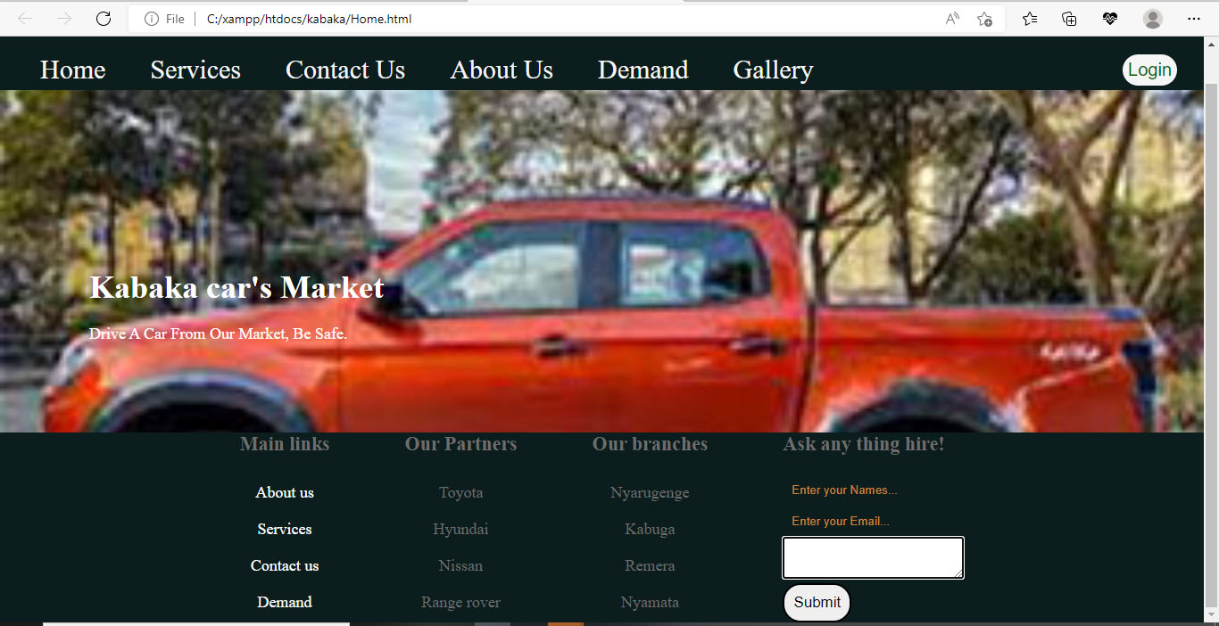

**4.System Implimentation**

**4.1 Home Page**



**4.2 Services Page**

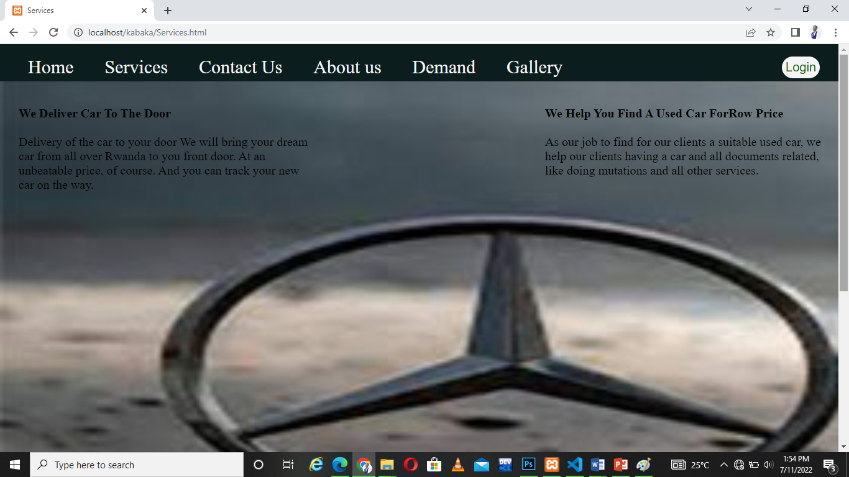

**4.3 Contact Us Page**

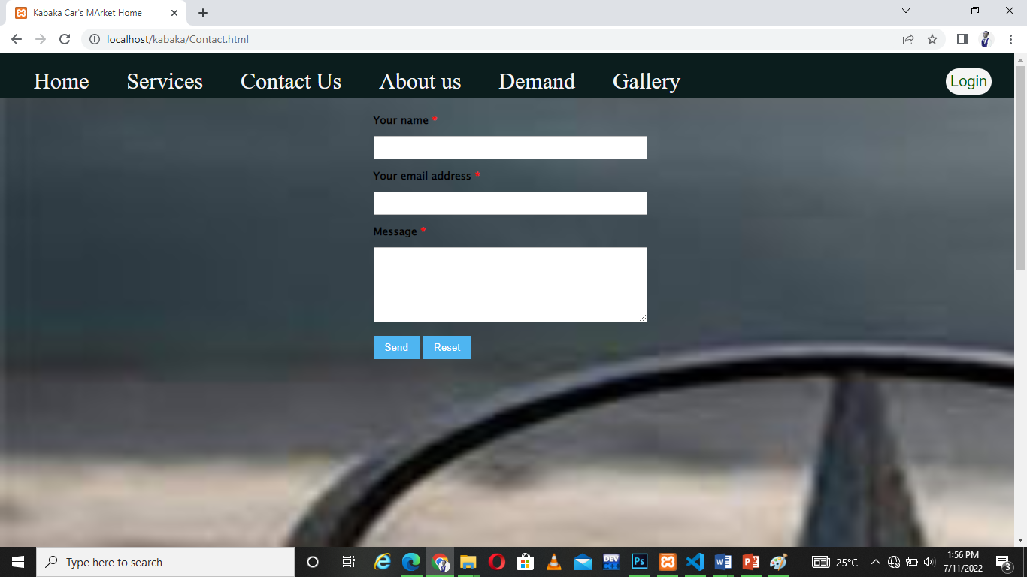

**4.4 About Us Page**

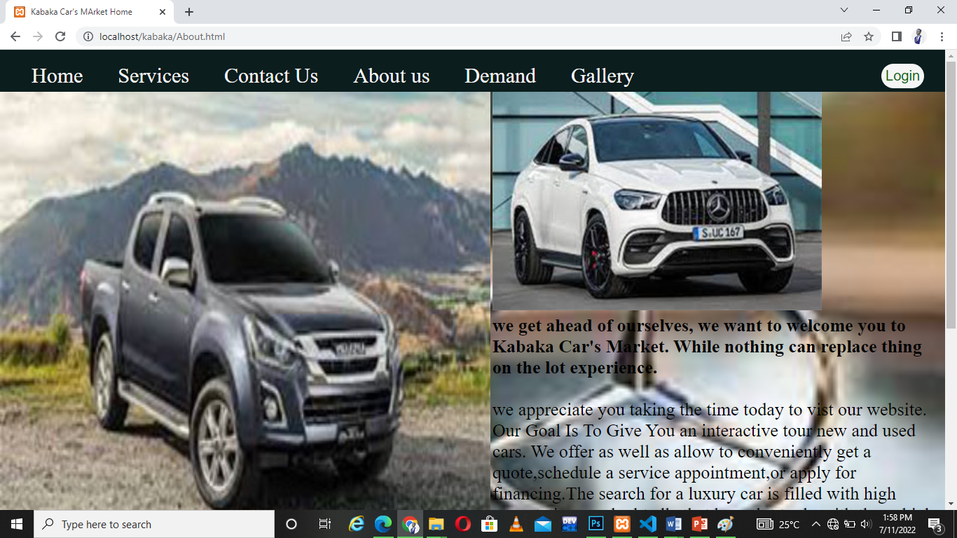

**4.5 Demand Page**

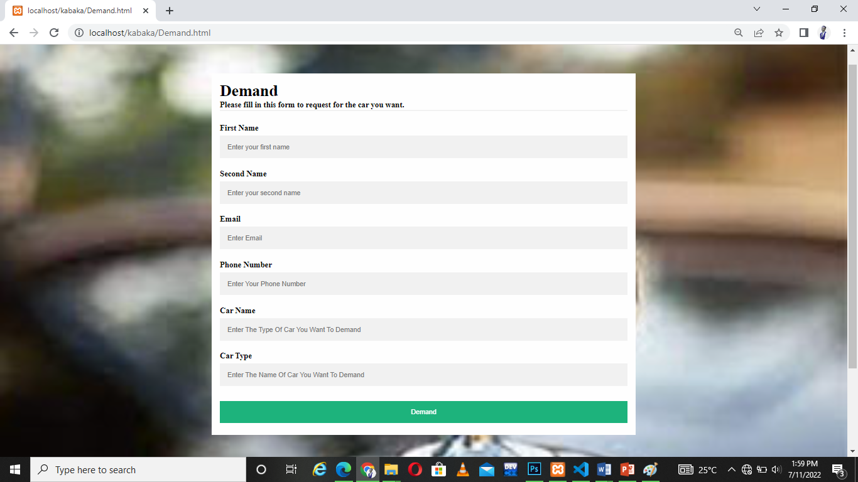

**4.6 Gallery Page**

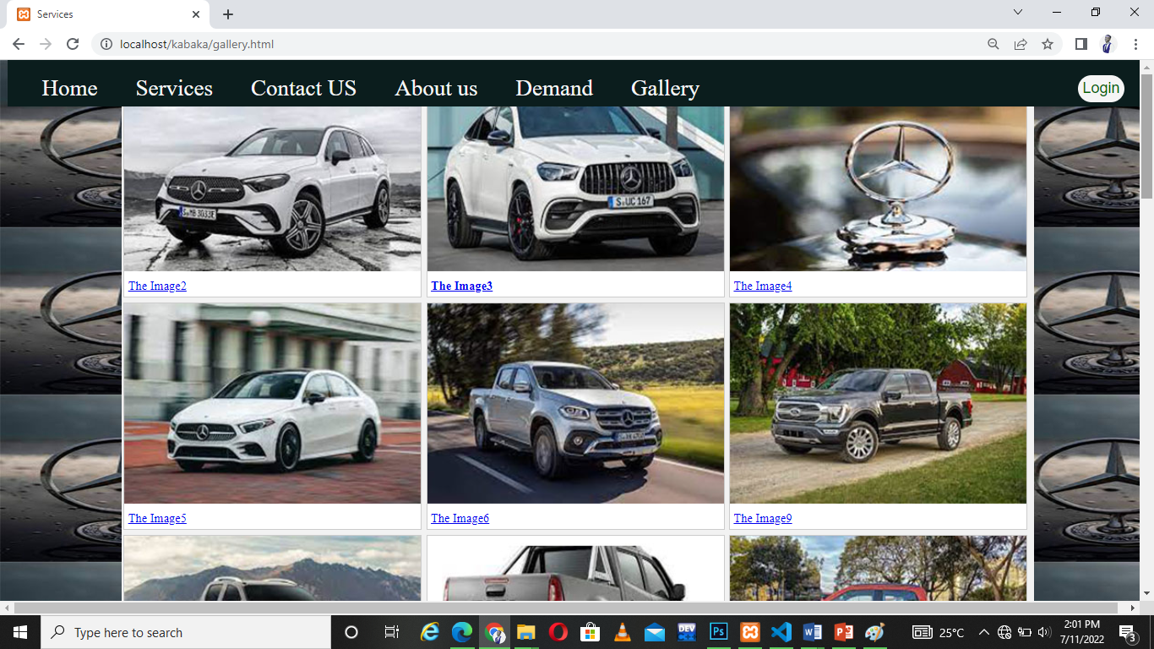

**4.7 Login Page**

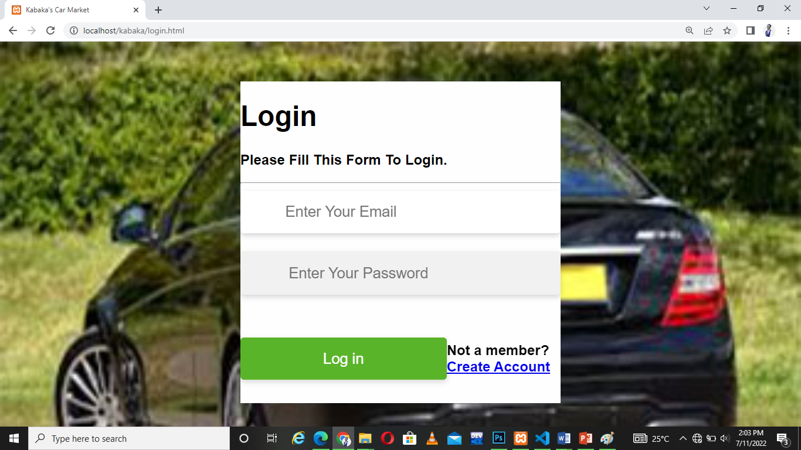

**4.8 Sign Up Page**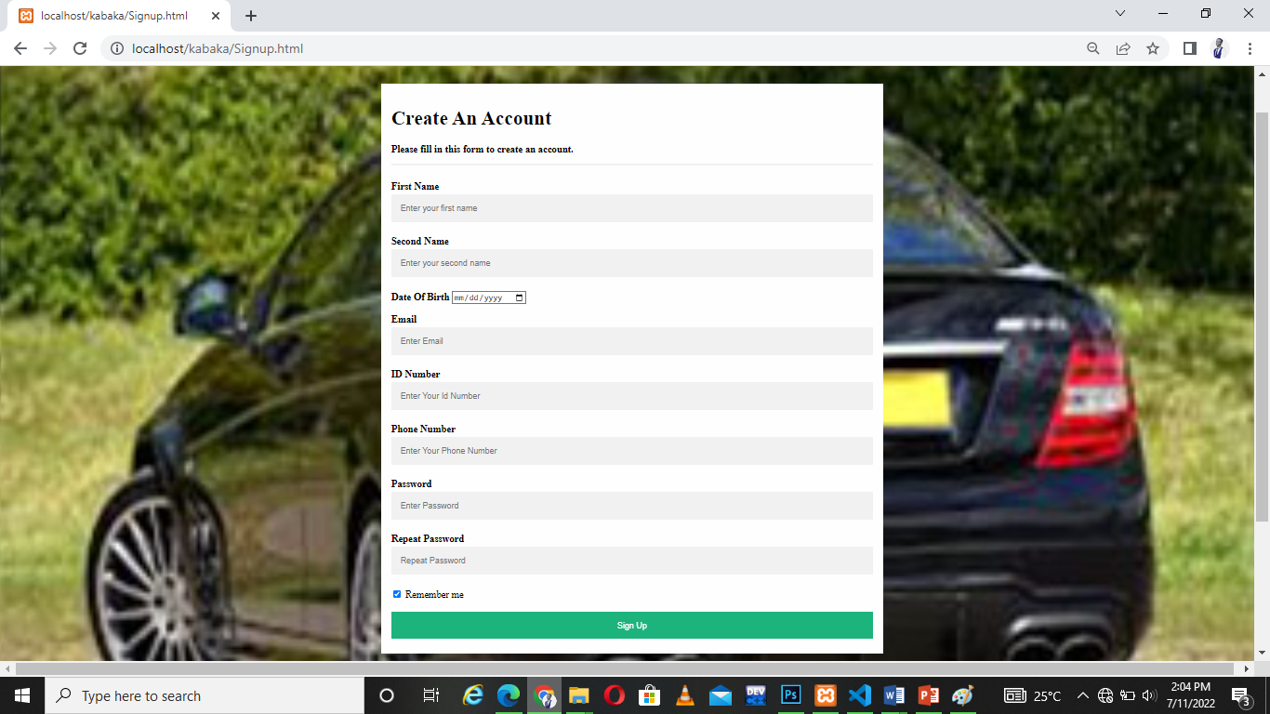

**4.8 My Database’s (Kabaka) Tables**

### **4.8.1 Sign up Table**

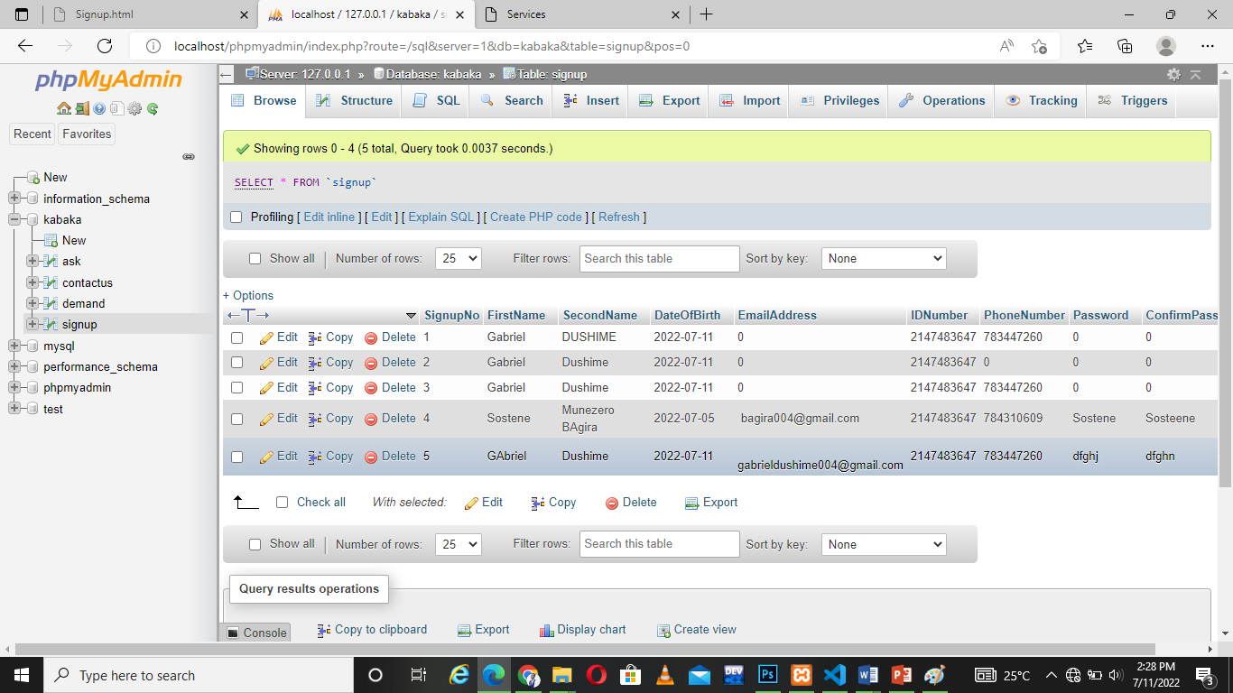

### **4.8.1 Demand Table**

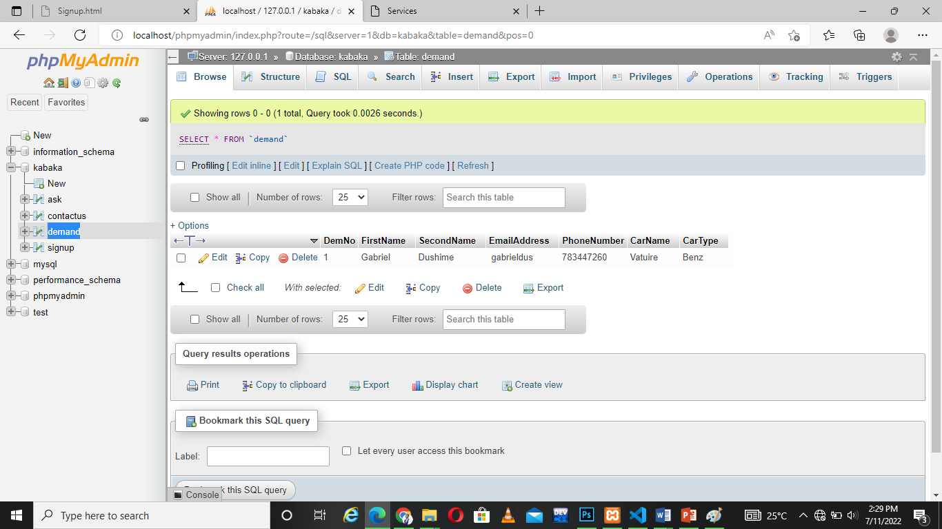

### **4.8.1 Contact Us Table**

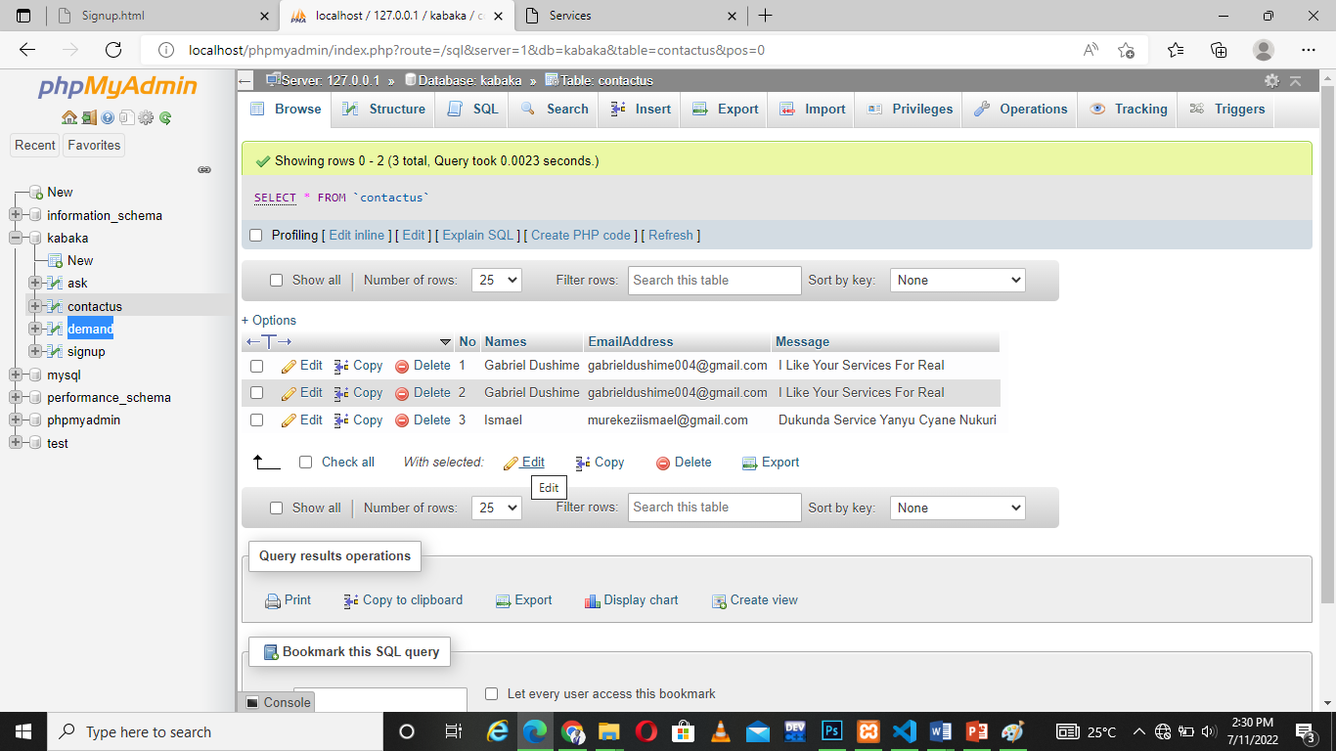

**5.Conclusion**

I did this my Project, And I met With Some issues Ta led me to nit finish well my project.

Like short Time According that I was Doing This Project Having Other courses that led me to not finish my project at the I level I wish to.

I did My Project Like to 65% according to all functionality must had had and what had now.

**6.Recommendation**

From This project I got learned Different way through which I can my web application. Also I get learned different languages like java script, Php, Html and css.

My recommendation to other students is I would encourage them trying finding a basic knowledge about the mentioned laungages above so that it can help them doing some tasks like creating a simple web pages, and doing some web application.

The great beneficially from this my project is that it will make easy finding used car to the people and minimizing the cost the used when finding the car from place to place.

**6.Appendix**

***LINK:***